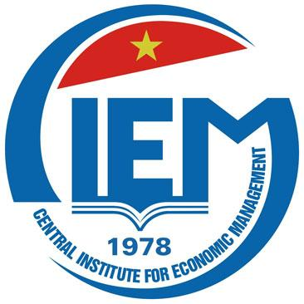 | 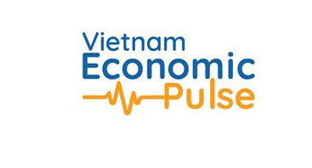
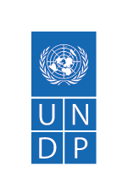
Viet Nam Economic Pulse Forum Sparks Dialogue on Technological Advancement and Sustainable Growth

Ha Noi 6 December 2023 – The UN Development Programme (UNDP) and the Central Institute for Economic Management, Ministry of Planning and Investment (CIEM, MPI), co-hosted the third annual Viet Nam Economic Pulse (VEP) forum today in Ha Noi. The event, held under the theme "Leveraging Technology to Foster Prosperity in Viet Nam," brought together business leaders, scholars, experts, and policymakers to delve into the transformative potential of new technologies, Industry 4.0, and the digital revolution.

The forum highlights the importance of science, technology and innovation for middle-income countries like Viet Nam. Discussion at the forum focused on directions suitable for Viet Nam's potential capacity in taking advantage of science and technology in economic development. Educators, scientists and business leaders shared their perspectives on seizing opportunities, training and investing in cutting-edge technologies like semiconductors and artificial intelligence, and building an innovative and competitive business environment.

UNDP Resident Representative Ramla Khalidi, in her opening remarks, emphasized, “Technological innovation, the energy transition and shifts in geopolitical strategies have created historic opportunities for Viet Nam to accelerate economic transformation, penetrate new markets for higher value-added goods and services and increase the sophistication and domestic content of exports. Viet Nam’s ability to capitalize on these opportunities will have important implications for the country’s ability to sustain productivity growth at higher level incomes—in other words, to avoid the middle-income trap”.

During the forum, CIEM experts presented “Overview Viet Nam’s economy 2023: The main driving forces for growth and development” while a representative from the Viet Nam Academy of Science and Technology discussed Science, Technology, and Innovation (STI) as key leverage point for Viet Nam in the Global Value Chain.

UNDP Senior International Economist Jonathan Pincus shared valuable insights into the middle-income trap and technology policy in Southeast Asia, contributing a global perspective to the discussions.

Speaking at the forum, President of the Central Institute for Economic Management Tran Thi Hong Minh shared: "From forums like this, the Central Institute for Economic Management has had more information to provide advices for the Ministry of Planning and Investment, for the Government to promulgate many economic development policies, including fundamental policies in forming new economic models in Viet Nam such as the night economy development project, circular economy development project, and sharing economy development project".

***
About Viet Nam Economic Pulse Forum:

Launched in 2021 by the Ministry of Planning and Investment and UNDP, the Viet Nam Economic Pulse Forum is an annual event designed to create a new, informal platform for discussions on Viet Nam's economic situation and development policy. The forum aims to stimulate dialogue on economic issues, incorporating a diverse range of voices beyond the conventional spectrum.

Website of the forum: https://vep.undp.org.vn/

For more information, please contact:
Nguyen Viet Lan, UNDP Communication Lead
phone: 0914436769, email: nguyen.viet.lan@undp.org

